
phgy311
lecture #: | date: | professor:
23 | Nov. 8, 2006 | Dr. Farookhi
24  25 | Nov. 10, 2006  Nov. 13, 2006 | Dr. Farookhi  Dr. Farookhi
announcements:
- Physio vs. Anatomy Hockey Game – Nov. 23rd 2:30-4:00 at McConell Arena. Come support our hockey team and get some free pizza in the stands!
- Clothing has arrived, so if you ordered any items come pick them up from the PULS lounge.

Edited By: Steph Rolin
Do Not Redistribute
set #8
PHGY 311 - Lecture 23 November 8, 2006
Writer: Natasha Fernando Dr. Farookhi

- Dr Farookhi
- Riaz.farookhi@mcgill.ca
- Office: F344, Royal Victoria Hospital
- Hours: Thursday, from 2 to 5PM
- Recommended book: Endocrinology (Hadley 5th ed).
- There are 2 copies on reserve.
- Read relevant chapters before coming to class (schedule is available on WebCT).
  - Make notes beforehand and take additional notes if Dr Farookhi says anything extra. Lectures should be posted beforehand or shortly after.
- In this section of the course, we will look at ligands, their response, what the tissue does with them, why it does it, and how the organism responds to it.

Endocrine system
- The endocrine system can be defined as communicating systems designed to maintain physiological homeostasis.
  - Exception: reproductive system
- The endocrine system consists of ligands and receptors.
- Ligands bind to their receptors, thereby stimulating them and giving rise to an intracellular response.
- An endocrine system can act in many different manners, although traditionally it was a system that secreted hormones into the bloodstream, and those hormones then acted on a distant target. Now we have many other types of endocrine systems.
  - A paracrine system secretes hormones that act on nearby cells, without ever entering the circulation.
  - An autocrine system is when the signaling cell is the responding cell.
  - There exist neuronal systems as well, and contact-dependent signaling (two cells must be touching) which are primarily found in developing systems.
- There is no need to memorize individual signaling molecules! Since signaling molecules from the same category act the same way, it is sufficient to know how to group the molecules based on
  - What they do
  - What class of families they belong to
  - What family of receptors they interact with
- Signaling molecules range from simple amino acids (modification of tyrosine) to larger proteins (insulin) to peptides (glucagon) to small molecules (steroids)

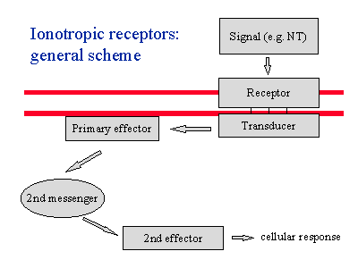
An Example: Coffee
- The active ingredient in coffee is caffeine, a phosphodiesterase inhibitor.
  - Phosphodiesterase is an enzyme that turns cAMP into AMP, ensuring that no accumulation of cAMP can occur.
  - Recall: cAMP is an intracellular second messenger that acts upon a second effector, giving rise to a cellular response.

- Caffeine bypasses the receptors and acts directly on the intracellular signaling molecule. It prevents the breakdown of cAMP, which results in vasoconstriction.
- Caffeine is a diuretic.
- In addition, when you drink coffee, the sugar enters your bloodstream. The increase in blood glucose is detected by glucose receptors on your pancreases.
- This increases insulin release, which blocks cAMP degradation. Through a cascade of events, you feel more awake.

Determinants of cell response
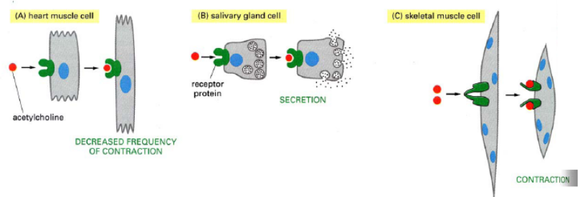
- The same ligand can cause different responses.
- In the heart muscle, ACh causes a decrease in contraction frequency.
- In salivary glands, ACh increases secretion.
- In skeletal muscle, ACh causes contraction.
- In all cases, the response to the same molecule through the same receptor is determined by cell type.

- However, not all ligands will bind to all molecules. Specificity of receptors is the key to determining which ligand will bind to it.
- If you expose a cell with NO receptors to NO, the cells respond with relaxation. But if the cell doesn’t have NO receptors, nothing will happen.
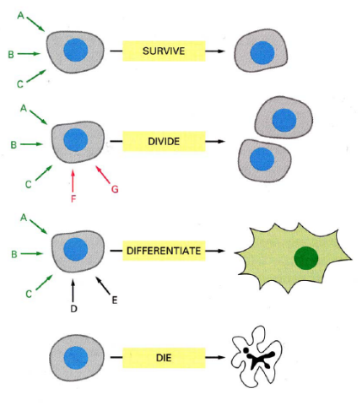
- In the heart muscle, ACh causes a decrease in contraction frequency.

- In addition to the importance of signaling receptor and cell type, the cell’s history (what hormones it has been exposed to) is also important.
- If you expose a cell to hormones A, B, C, it survives.
- If you expose if to A, B, C, and then to F, G, the cell divides.
- If you expose it to A, B, C, then D, E, it differentiates.
- If you expose it to D, E, it dies.

- So, hormones require specific receptors on their target cells. However, the target cell itself has the ability to respond differently to the same hormone based on cell type and cell’s history.
- Cell response is based on cell type, specificity of receptors and cell’s history.

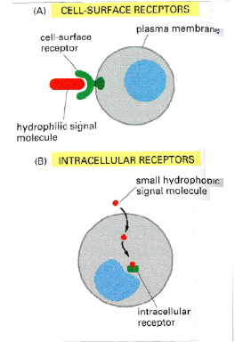
Classes of Receptors
- There are two major classes of receptors.
  - Cell surface receptors → signaling molecule cannot get inside the cell on its own. It has to bind to something on cell surface.

  - Intracellular receptors → it responds to hormones that can cross plasma membrane. They are hydrophobic. This process involves cell differentiation
- Within the classes, there are several types of receptors
- Voltage gated ion channel receptors, Transmembrane helix receptors, tyrosine kinase receptors, etc

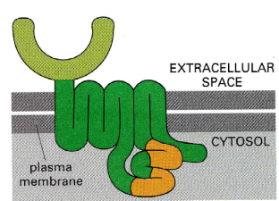
- The ligand family that each receptor interacts with is specific.
- For instance, the 7 transmembrane receptors or ‘G-protein coupled receptors’ interact with whole host of different ligands.
  - They are the most abundant and oldest. All eukaryotes have it.
- Throughout this course we will look at families of receptors and families of ligands.

Cell Surface Receptors
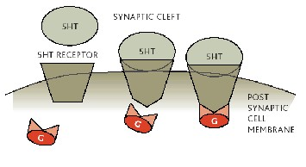
- The ligand binds to receptor.
- This binding causes changes within the receptor which then triggers the intracellular effector molecule
- The triggered effector molecule will give rise to amplification, change in phosphorylation state of enzymes, regulate events, metabolic pathways, homeostasis, gene expression, or development

- The problem with this is that an intracellular messenger like cAMP is only 300Da. The probability of it interacting with PKA by random chance is too low. Instead, PKA is kept localized near the receptor proteins where cAMP will be produced. This is achieved through scaffolds, which lock them into 2-dimensional space.

G-Protein Coupled Receptors (GPCRs)
- GPCRs are cell surface receptors.
- Also called 7 transmembrane linked receptors.
- These receptors have an extracellular ligand-binding domain, 7 transmembrane domains, and an intracellular G-protein binding loop.
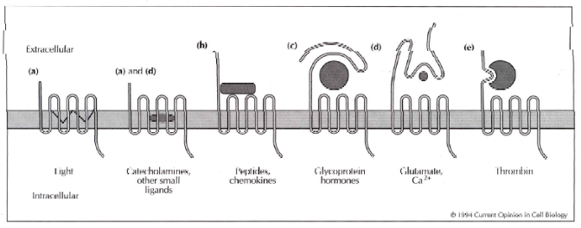
- Many ligands can trigger GPCRs. Wit the expecting of light, small molecules require elaborate extracellular ligand binding portions.
- This ensures that there is precise specificity in binding, even the molecule is tiny. The receptor molecule has to ‘look’ at it from all angles.
- This is unnecessary for larger molecules.
- The glycoprotein binding site is not as elaborate as only 2-3 parts must be recognized.
.
- A GPCR interacts with intracellular G-proteins.
- Portions of G-protein are embedded into membrane to bring it into proximity with the receptor
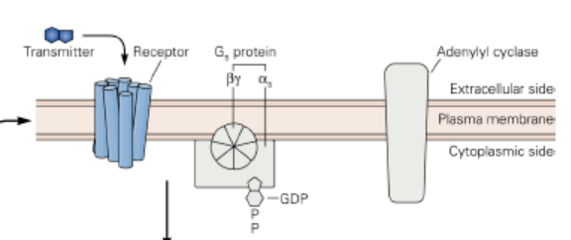
- The signaling ligand molecule arrives and causes conformational changes in the receptor. This results in G-protein activation.
- There is a GDP-GTP binding site in alpha subunit. The alpha unit releases GDP and takes up GTP, becoming activated.
- It then dissociates from beta-gamma subunit and interacts with an effector molecule (eg adenylyl cyclase)
- As a consequence of this activation, the beta gamma complex also dissociated from the alpha subunit and it can also interact with other effector molecules (eg phospholipases)
- The active alpha subunit now interacts with a target protein and through a cascade of events, the cell responds.

- Within this pocket, there is self-limitation as the alpha subunit contains GTPase. It will consequently break down GTP to GDP causing the complex to reassemble and dissociate from the inactive receptor.
- Consider: adenylyl cylase will activate PKA through cAMP binding.
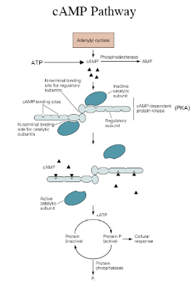
  - Once PKA is activated, it phosphorylates intracellular enzymes, changes metabolism, changes homeostasis or phosphorylates transcription factors.
  - This will give rise to the transcription of new genes or inhibition of the transcription of new genes
  - There is well known biding element called CRE (camp response element) which binds to transcription factors
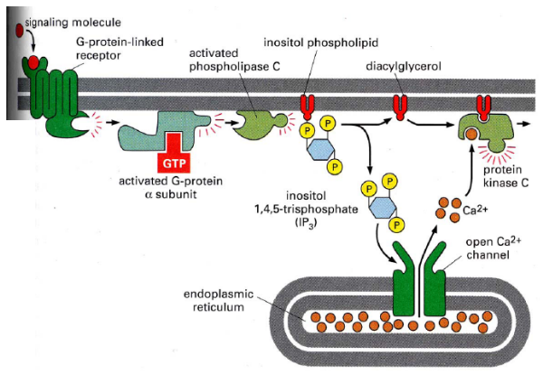
- Consider another effector molecule, phospholipase C. It will break down membrane phospholipids to give rise to IP3 + DAG
- ‘2 transducers for the price of 1’
- There are 2 G-protein activations, 2 effector molecule activations and then, IP3 and DAG will cause intracellular calcium to be released and calcium then interacts with protein kinase C.
- This works the same way as other phosphorylating enzymes and can give rise to other phosphorylating transcription factors.

- In this lecture, we have seen how extracellular signaling molecules can alter protein function by phosphorylating or dephosphorylating, activating or inactivating enzymes, altering gene expression, changing metabolism or changing the phenotype of the cell.
- Let’s see this in an experiment.

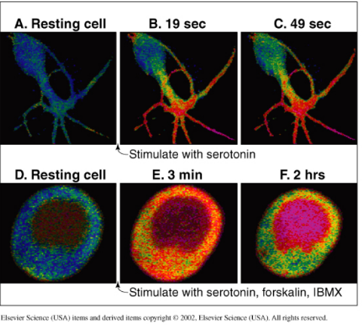
An Experiment
Series of fluorescents for calcium in a cell that demonstrate how scaffolding affects localization of intracellular Ca++ concentration.

- 1st experiment: When one cell is stimulated by serotonin, Ca++ fluoresces red.
  - Serotonin stimulation gives increases cAMP which increase intercellular Ca++ concentrations.
  - The effect is localized.
- 2nd experiment: When you stimulate the same cell with serotonin and two other hormones (phosphalin and IBMX→ similar structure to caffeine), we see red all over the whole cell.
  - This shows that with phosphalin and IBMX, there is great outpouring of cAMP which cannot be broken down. Consequently, the whole cell responds to cAMP via various pathways.
  - This reinforces the importance of scaffolding and localization.

PHGY 311 – Lecture 24 November 10, 2006
Writer: Ana Coutinho Dr. Farookhi

CONTINUATION OF PROTEIN RECEPTORS AND SIGNALING MECHANISMS

- Dr. Farookhi assumed at we all knew how proteins are made, assembled and exported, so review this if it is unclear

SCAFFOLDING
- Scaffolding is a structural entity which allows for the assembly of downstream proteins to signaling molecules.
    - Used as support
- There are some signaling pathways where the scaffolding structure has been determined, but it is unknown whether all signaling pathways use this mechanism.
    - Scaffolding is still a bit unclear.

TERMINATING THE SIGNAL
  - There are a couple of ways a signal can be terminated.
    - In the nervous system, the transmitter is destroyed or removed from the synapse.
      - Agonist re-uptake.
    - For hormones, their receptors are either blocked from further signaling [desensitization] or endocytosed [downregulation]
  - G-protein receptors use both of these mechanisms

  - How do you distinguish between desensitization versus downregulation?
1. Tag the ligand
2. Add the ligand to the cell
3. Determine if it binds to the cell
      - If the ligand binds but there is no response → desensitization
      - If the ligand does not bind → downregulation

MUTATIONS OF G-PROTEIN COUPLED RECEPTORS
- Loss of Function Mutations:
    - Mutation in gene receptor or protein that gives rise to an effect, where the function is lost [can be recessive or dominant]
      - Retinitis pigmentosa: result is poor vision because there is trouble with signal transduction and pigment regeneration
  - Gain of Function Mutations:
    - Mutation in receptor or protein that gives rise to an effect, where there can be a gain of function, like turning on a receptor.
      - Retinitis pigmentosa: driving the system so hard that you are bleaching out all the photoreceptors to prohibit vision transduction
- Loss of function and gain of function mutations can result in the same disease, depending on whether the receptor or the protein is affected
  - Receptor doesn’t work if there’s a loss of function or if the systems been overused. The end result is the same.
- Lutenizing Hormone mutation
  - In the male, this causes precocious male puberty
    - LH leads to puberty in the male. With this type of mutation, LH is being released too soon. It stimulates the onset of precocious puberty.
  - In the female, nothing happens
    - Female puberty does not rely on LH, so the same mutation in females does not have the same result.
  - From the LH example, we can see that not only does cell specificity, hormone specificity, and cell history determine signaling outcome, timing plays a part in hormone function

TYROSINE KINASE RECEPTORS [RTKs]
  - The receptor is the relay and amplifier
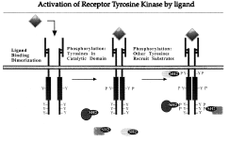
    - Receptor and kinase are together to increase efficiency
    - Internal signal is incorporated into receptor
  - Family is more directed
    - Not 100%, but most RTKs are associated with growth factors

  - The key to these receptors activity is that they need to dimerize to have kinase activity to propagate the signal
    - Form homodimers to function; brought together by ligand
      - Requires that two regions of the ligand are symmetrical, not necessarily the entire molecule. The similar parts would bind on each subunit of the dimer
- Once activated by the ligand, each subunit of the dimer phosphorylates the other to change structure of the kinase domain to be active

  - Possible that they exist as a preformed dimer, but require the ligand to phosphorylate each other
    - Unknown whether they always exist as a dimer, or only sometimes, but it doesn’t really matter. The end result is the same.
  - At this time, it is assumed that both separated subunits that dimerize and preformed dimers exist in the cell
    - Will have different times delays to send signal
    - Fast-activing: pre-formed
    - Slower-activting: must dimerize
    - Produce the same effect

RAS PROTEIN CASCADE
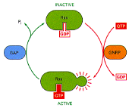
  - Phosphorylation of tryrosine (Tyr) residues creates sites on receptor that can be recognized by other molecules in the cell, which will the slot into these sites
    - These adapters then transmit the signal. Many use a G-protein-alpha-like complex called Ras

- Ras needs to have a GDP exchanged for a GTP in order to become activated.
    - This is where amplification comes in because numerous Ras proteins can be activated with one RTK
- Unlike the alpha subunit of the GPCRs, Ras does not have intrinsic GTPase activity. It requires other proteins to facilitate GTP-GDP exchange, thereby inactivating it.
    - Therefore, mutations of the Ras pathway causes numerous types of cancer as control of growth is lost.

- Once activated, kinases can alter cell metabolism or gene expression.
    - This is the reoccurring property of signaling pathways

TGFB FAMILY
- Ser-Thr kinase—activates Serine and Threonine residues.
- This family has heterodimers, as two different subunits come together with the ligand to produce an effect through kinase domain

  - Propagation of the signal requires smads [somatic mothers against TGFb]
    - Proteins were discovered through absence of effect in flies because there was no transcription of the gene. This was due to lack of propagation of signal via smads
  - Phosphorylated Smad complexes acts as the transfer gene
    - To activate or repress transcription of genes

CYTOKINES
- Cytokines include interleukins, interferons, growth hormone (GH), erythropoetin (EPO), and prolactin.
- The receptor and the kinase are not one unit. Receptors must recruit kinase [JAKs] upon activation
    - JAKs located next to receptor

1. Binding of ligand to the receptor causes conformational change, which recruits the kinase
2. Cross phosphorylation of intracellular subunits of the receptor
3. STATs [adapter proteins] are activated through interaction with intracellular portion of receptor
4. STATs move to nucleus to bind to DNA to active gene transcription
INTRACELLULAR RECEPTORS
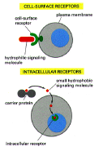
- Ligands that activate intracellular receptors are hydrophobic.
    - They diffuse through the lipid bilayer into the cell and bind to intracellular receptors.
      - Cortisol, testosterone, estradiol, etc

  - Testosterone and estradiol are very similar, they differ by only.one methyl group.
    - Receptors must show exquisite specificity as testosterone and estradiol share the same steroid backbone.
      - Requires approximately 1000x more testosterone than estradiol to knock estradiol off its receptor

  - The ligand can bind to the receptor in either the cytoplasm [glucocorticoid] or in the nucleus [estradiol]
    - If the two components bind in the cytoplasm, they together move to the nucleus
- Once the receptors are in nucleus, binding occurs for interaction with DNA or mRNA
  - Can activate or deactivate transcription of genes
- Steroid hormones are BOTH the message and part of the transduction mechanism.

  - These receptors work by dimerization and recognition of upstream sequences, which are commonly palindromic [but not always: sometimes are repeats]
    - Dimers can therefore be back to front, front to front, back to back as a result of the palindromic nature of the sequences to which they bind
    - They bind to DNA, which causes a conformational change in the dimer
    - This change alters transcriptional activity of genes

  - When you have your receptor without a ligand, it is bound to protein 90, which keeps it in the inactivate state. Once the ligand bind, there is a conformational change releasing Hsp90 and allowing the receptor to dimerize and bind to DNA sequences

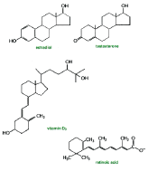
STERIOD HORMONES
  - Cholesterol is the “grand-daddy” of steroid hormones
    - 27 carbons
    - 4 rings [a, b, c, d]

  - To make a steroid hormone:
    - 1. Produce pregnendone: involves chopping off the cholesterol side chain in the mitochondria
      - This is the critical, regulated step [there are other regulated steps, but this is the most important]
    - 2. The proteins then moves to the smooth ER for processing [to corticoids or sex hormones]
    - To recognize a steroid synthesizing step, look for tubular mitochondria, smooth ER, and lipid droplets

- Summary of Receptor Molecules: signaling molecule can modulate gene transcription by direct participation or by activating latent nuclear or cytoplasmic transcription factors

PHGY 311 – Lecture 25 November 13, 2006
Writer: Queenie Chow Dr. Farookhi

Sample Quiz Question: FSH Dose response on intracellular cAMP production
- The graph shows cAMP responses on granulose cells in vitro, stimulated with different concentrations of FSH.
- Cells were obtained from either untreated rats or estradiol-treated rats.
- Intracellular concentrations of cAMP measured at 30 minutes after the application of FSH at the indicated doses.
- Remember: stimulation of FSH receptors induces cAMP production

Question 1: What is the effect of estradiol on granulose cells with regard to FSH responsiveness? Provide an estimate of the effect and how you derived it.
- Treating rats with estradiol increases FSH responsiveness in rat cells at all doses
- There is a 100-fold increase in FSH responsiveness in estradiol-treated rats (at all FSH concentrations). The same intracellular cAMP concentration between the two curves, we see that they correspond to a 100-fold difference in FSH concentrations on the logarithmic x-axis.
  - Note: The curves here are parallel. If the curves are not parallel, specify the increase/decrease in responsiveness at 50% of the max cAMP concentration. To be thorough, do the same for 80% or 20% of the maximum cAMP concentration.
Question 2: Additional experiments showed that estradiol had not changed the number of FSH receptors nor the trimeric G protein content of the cells. What do you think is the most likely explanation for the estradiol effect? Be specific.
- Simplest explanation: estradiol inhibits the effect of phosphodiesterases, which break down cAMP.
- Reasoning:
  - Effect of estradiol must be downstream to the production of cAMP (ie. it does not affect adenylyl cyclase) because the same maximum amount of cAMP is being produced.
  - Affecting the breakdown of cAMP, and not production, would be consistent with the parallelism in the two curves.
  - Estradiol does not affect the pituitary in negative feedback because these are in vitro cells.
30
20
10
50%
cAMP concentration
FSH concentration
10⁻¹³
10⁻¹²
10⁻¹¹
Estradiol-treated
Control
Dose-response of granulose cells to FSH stimulation (Rough Replication)

Hormone Experiments – How Scientists Figure It Out
- Berthold’s experiment in 1894 was the first endocrine experiment
- An example of a bioassay (short for biological assay), which measures the effect of a substance on a living organism.
- The secondary male characteristics of developing cock were studied.
- Remove both testes.
  - Results: Smaller combs and wattles, no interest in hens, weak crow, listless fight behaviour
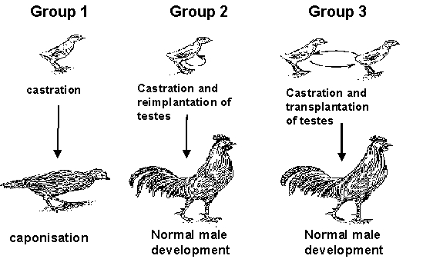
  - Hypothesis: There is some relationship between the testes and the secondary male characteristics. Check hypothesis with experiment #2.
- Replace one of the removed testes.
- Results: Normal characteristics are restored. In addition, the one testis is larger than normal.
- Extension of hypothesis: Compensation for a missing testis occurs, the size of the remaining testis is increased. Suggests that something modulates for compensation.
- Exchange testis from one chicken to another
- Results: Normal characteristics. The transplanted testis is not rejected
- Analysis: Response is not due to the chicken’s own testes. Hence, some secretion (i.e. hormone) from the testes must be affecting the characteristics.

Another famous bioassay: Human chorionic gonadotropin (hCG)
- Tested for in the blood or urine of potentially pregnant women
- Human pregnancy test In the 1950s: Injecting the urine of a pregnant woman (containing hCG) into a rabbit would cause the rabbit to ovulate. After injection, the rabbit was killed and observed for evidence ovulation. Ovulation meant the woman positively pregnant.
- Today, we use a much simpler method to test for pregnancy.

Determining the amount of an antigen (e.g. ligand, hormone, etc) in a solution
- Radioactively-tagged antigen (Ag*) will bind to its antibody (Ab) and form an equilibrium with the corresponding antigen-antibody complex (Ag*-Ab) in solution.
- By doing centrifugation, which separates heavier complexes from lighter ones, the amount of Ag*-Ab complex in a solution (ie. the binding of Ag* to Ab) can be measured
- Unlabelled antigens (Ag) introduced to the solution will compete with Ag* for binding to the Ab. Increasing the amount of Ag in a solution will reduce the amount of Ag*-Ab because Ag-Ab are formed instead.
- A binding curve can be built (drawing shown is rough replication)
  - B₀ = binding of Ag* in absence of Ag
  - B = measured binding of Ag*
B/B₀
[Ag], ng/tube (log scale)

- For a sample containing Ag* and an unknown quantity of Ag: if we measure B and know the B/B₀ ratio, then we can determine the amount of unlabelled Ag that was in the sample.
- Ab could be a receptor and Ag could be a hormone that binds specifically to the receptor
- Building these curves will allow us to determine hormone concentrations in a sample.
- Applications: e.g. human pregnancy tests for determining the amount of hCG in urine.

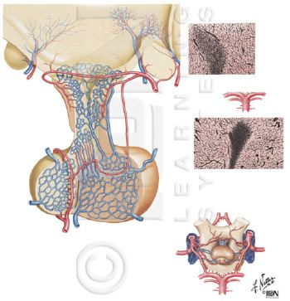
The Hypothalamus
Origins
- the posterior pituitary (pars nervosa) is an out-pocketing of the brain, and is made of nervous tissue
  - neurons from the paraventricular nuclei (supraoptic nuclei) project into the posterior pituitary
- the anterior pituitary (pars distalis) is derived from the ectoderm (palate)
- the intermediate lobe (pars intermedia) is of unknown origin
Hormones
- The posterior pituitary produces: ADH (aka. vasopressin), Oxytocin
- The anterior pituitary produces: ACTH, TSH, FSH, LH, Prolactin, GH
  - There is at least one or more releasing hormone from the hypothalamus regulating the release of each of these anterior pituitary hormones
  - These hormones are small (TRH = 3 amino acids; LHRH = 10 aa; Somatostatin = 14 aa)

  - The half-life of a hormone:
    - is only a few minutes
    - is shorter for smaller hormones
    - can be lengthened to 30 or 60 minutes by adding sugar moieties on peptide hormones
      - sugar moieties protect hormones (especially lysine and arginine residues) from cleavage by proteases
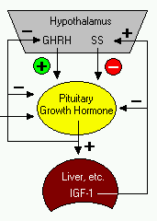
  - Since the anterior pituitary is not made of nervous tissue, the hypophyseal portal system circulating blood between the hypothalamus and the anterior pituitary is very important. The two tissues must be in close proximity to each other or else hormones will be degraded.

Example of a classical feedback loop: GH
- Growth hormone releasing hormone (GHRH, aka. somatoliberin) and growth hormone inhibiting hormone (GHIH, aka. somatostatin) are released from the hypothalamus
- They act on somatotropes in the anterior pituitary to stimulate the release of growth hormone (GH)
- GH stimulates the release of insulin-like growth factor (IGF) in body cells
- Increased levels of IGF stimulates release of GHIH and inhibits GHRH in a classical negative feedback loop

- Another example of a classical feedback loop: CRH which stimulates release of ACTH and acts on the adrenal glands

Prolactin
- prolactin secretion is unique: it is inhibited by dopamine secreted by the hypothalamus
- if the hypophyseal portal system is severed, the only anterior pituitary hormone detectable would be prolactin

Homology between FSH, LH, TSH, and hCG
- these four glycoproteins are heterodimers
- they share an almost identical α-subunit, and differ in their β subunits
- β subunits determines the receptor specificity
- both α and β subunits are required for a functional hormone, hence their receptors bind to both subunits

